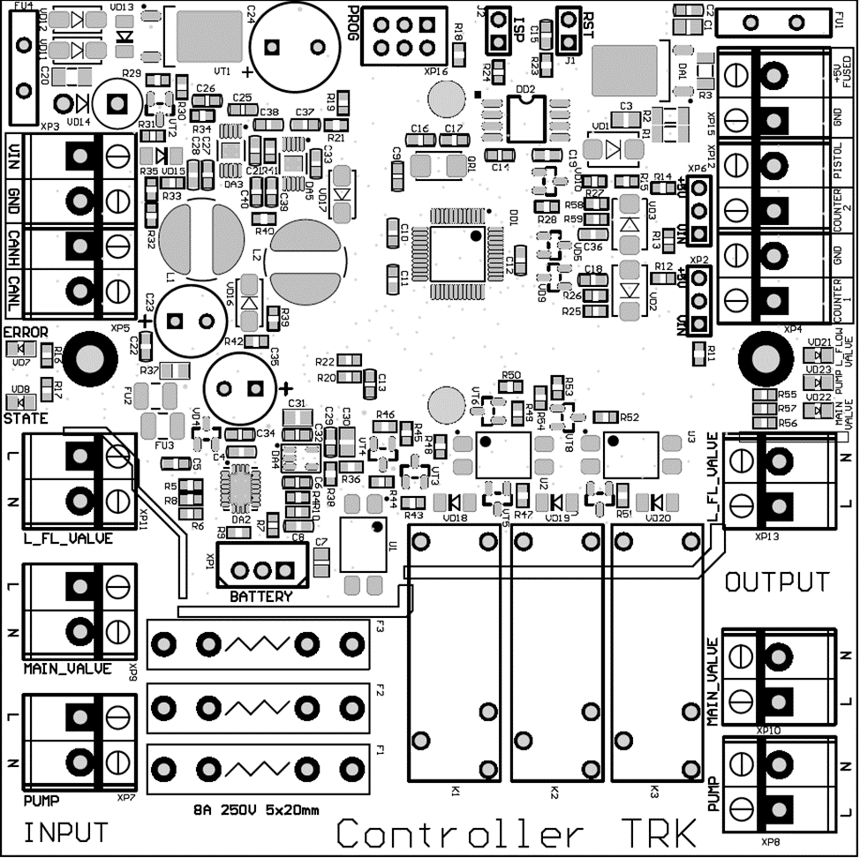

L

N

GND

GND

RELAYS IN

-V

+V

Pistol

GND

-V

+V

Counter 2

Counter 1

GND

N

Low L

Main L

RELAYS OUT

Counters OUT

Pistols OUT

PUMP OUT

